25.9.19 Editors - Properties Editor - Particle Tab - Children panel
Detailed table of content 1
Children panel 4
Children panel - Type None 4
Child Type 4
Children panel - Type Simple 4
Children panel - Type Simple - Clumping subpanel 5
Use Clump Curve 5
Clump 6
Shape 7
Twist 7
Use Twist Curve 7
Clump Noise 7
Children panel - Type Simple + Interpolated - Roughness subpanel 7
Use Roughness Curve 7
Roughness 9
Size 9
Uniform, Size 9
Endpoint, Shape 9
Random, Size, Threshold 9
Children panel - Type Simple + Interpolated - Kink subpanel 9
Kink Type 9
Children panel - Type Interpolated 11
Display Amount 11
Render Amount 11
Length 11
Threshold 11
Seed 11
Virtual Parents 11
Long Hair 11
Children panel - Type Interpolated - Parting subpanel 12
Parting 12
Min 12
Max 12
Children panel - Type Interpolated - Clumping subpanel 12
Use Clump Curve 12
Clump 13
Shape 14
Clump Noise 14

Detailed table of content
Detailed table of content
Detailed table of content 1
Children panel 4
Children panel - Type None 4
Child Type 4
None 4
Children panel - Type Simple 4
Simple 4
Display Amount 4
Render Amount 4
Length 4
Threshold 4
Seed 4
Size 4
Random Size 5
Radius 5
Roundness 5
Children panel - Type Simple - Clumping subpanel 5
Use Clump Curve 5
Selecting Points 5
Adding Points 5
Navigation elements 6
Zoom in and out 6
Tools 6
Reset View 6
Vector Handle 6
Auto Handle 6
Extend horizontal 6
Extend vertical 6
Auto Clamped Handle 6
Reset Curve 6
Use Clipping 6
Delete Points 6
Clump 6
Shape 7
Twist 7
Use Twist Curve 7
Clump Noise 7
Clump Noise Size 7
Children panel - Type Simple + Interpolated - Roughness subpanel 7
Use Roughness Curve 7
Selecting Points 8
Adding Points 8
Navigation elements 8
Zoom in and out 8
Tools 8
Reset View 8
Vector Handle 8
Auto Handle 8
Extend horizontal 8
Extend vertical 8
Auto Clamped Handle 8
Reset Curve 9
Use Clipping 9
Delete Points 9
Roughness 9
Size 9
Uniform, Size 9
Endpoint, Shape 9
Random, Size, Threshold 9
Children panel - Type Simple + Interpolated - Kink subpanel 9
Kink Type 9
Nothing 9
Curl, Radial, Wave, Braid 10
Amplitude 10
Clump 10
Flatness 10
Frequency 10
Shape 10
Spiral 10
Amplitude 10
Randomize Amplitude 10
Axis 10
Randomize Axis 10
Frequency 10
Shape 11
Steps 11
Children panel - Type Interpolated 11
Display Amount 11
Render Amount 11
Length 11
Threshold 11
Seed 11
Virtual Parents 11
Long Hair 11
Children panel - Type Interpolated - Parting subpanel 12
Parting 12
Min 12
Max 12
Children panel - Type Interpolated - Clumping subpanel 12
Use Clump Curve 12
Selecting Points 12
Adding Points 12
Navigation elements 13
Zoom in and out 13
Tools 13
Reset View 13
Vector Handle 13
Auto Handle 13
Extend horizontal 13
Extend vertical 13
Auto Clamped Handle 13
Reset Curve 13
Use Clipping 13
Delete Points 13
Clump 13
Shape 14
Clump Noise 14
Clump Noise Size 14

Children panel
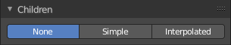
Children are Hair or Emitter particles originating from individual particles. They allow to work with a relatively low amount of Parent particles. Which reduces the calculation effort.
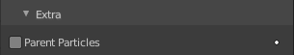
If you activate children, then the parents are no longer rendered. They can be reenable in the Render panel in the Extras subpanel. Parent Particles. By default, parent particles are not rendered because the shape of the children can be quite different from that of their parents.

Children panel - Type None

Child Type

None
No children are generated. No settings.

Children panel - Type Simple

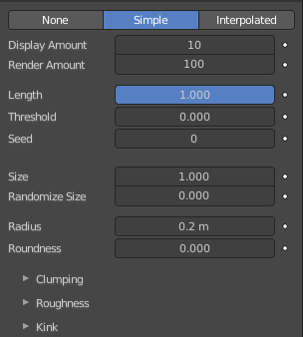
Simple
Children are emitted from the parent position.

Display Amount
The number of children in the 3D Viewport.

Render Amount
The number of children to be rendered.

Length
Length of child paths.

Threshold
Amount of particles left untouched by child path length.

Seed
Offset in the random number table for child particles, to get a different randomized result.

Size
A multiplier for children size.

Random Size
Random variation to the size of child particles

Radius
The radius in which the children are distributed around their parents. This is 3D, so children may be emitted higher or lower than their parents.

Roundness
The roundness of the children around their parents. Either in a sphere (1.0) or in-plane (0.0).

Children panel - Type Simple - Clumping subpanel
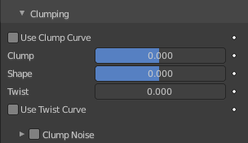
Clumping allows as the name says to break the even look, and clump particles together.

Use Clump Curve
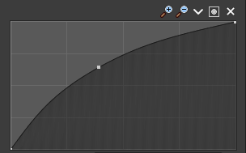
Use a Curve instead of parameters to adjust the clumping.


Selecting Points
You can select curve points. This reveals two edit boxes for the x and y coordinate of this point.
Selected points can be moved around. Left click at them, hold the mouse button down and move them to a new location.


Adding Points
You can add new curve points by simply left clicking at the curve. Move the mouse to position them where you need it.

Navigation elements
The navigation elements at the top are described from left to right.

Zoom in and out
The two buttons with the magnifying glass at it zooms in and out in the curve window.

Tools
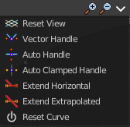
Tools is a menu where you can find some cuve related tools.

Reset View
Resets the curve windows zoom.

Vector Handle
Set handle type to Vector.

Auto Handle
Set handle type to Auto.

Extend horizontal
Extend the curve horizontally before the first and after the last curve point.

Extend vertical
Extend the curve vertically before the first and after the last curve point.

Auto Clamped Handle
Set handle type to Auto Clamped.

Reset Curve
Resets the curve to the initial shape.

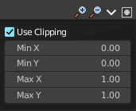
Use Clipping
Clipping options. Set up clipping for the stroke.

Delete Points
Deletes selected curve points.

Clump
Clumping amount along child strands. The children may meet at their tip (1.0) or start together at their root (-1.0).

Shape
Form of Clump. Either inverse parabolic (0.99) or exponentially (-0.99).

Twist
Number of turn around parent along the strand.

Use Twist Curve
Use a Curve instead of parameters to adjust the twisting of the particles.
For controls see above, clump curve.

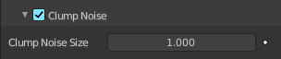
Clump Noise
Creates random clumps around the parent hair.

Clump Noise Size
The size of clump noise.

Children panel - Type Simple + Interpolated - Roughness subpanel
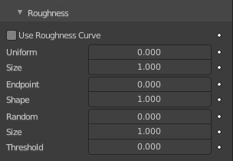
Give the particles a roughness.

Use Roughness Curve
Use Curve Widget instead of parameters.

Selecting Points
You can select curve points. This reveals two edit boxes for the x and y coordinate of this point.
Selected points can be moved around. Left click at them, hold the mouse button down and move them to a new location.

Adding Points
You can add new curve points by simply left clicking at the curve. Move the mouse to position them where you need it.

Navigation elements
The navigation elements at the top are described from left to right.

Zoom in and out
The two buttons with the magnifying glass at it zooms in and out in the curve window.

Tools
Tools is a menu where you can find some cuve related tools.

Reset View
Resets the curve windows zoom.

Vector Handle
Set handle type to Vector.

Auto Handle
Set handle type to Auto.

Extend horizontal
Extend the curve horizontally before the first and after the last curve point.

Extend vertical
Extend the curve vertically before the first and after the last curve point.

Auto Clamped Handle
Set handle type to Auto Clamped.

Reset Curve
Resets the curve to the initial shape.

Use Clipping
Clipping options. Set up clipping for the stroke.

Delete Points
Deletes selected curve points.

Roughness
Amount of location dependent roughness.

Size
Size of location dependend roughness.

Uniform, Size
It is based on children location so it varies the paths in a similar way when the children are near.

Endpoint, Shape
“Rough End” randomizes path ends (a bit like random negative clumping). Shape may be varied from <1 (parabolic) to 10.0 (hyperbolic).

Random, Size, Threshold
It is based on a random vector so it is not the same for nearby children. The threshold can be specified to apply this to only a part of children. This is useful for creating a few stray children that will not do what others do.

Children panel - Type Simple + Interpolated - Kink subpanel
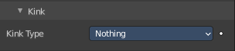
With Kink you can rotate the children around the parent.

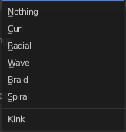
Kink Type

Nothing
Deactivated.

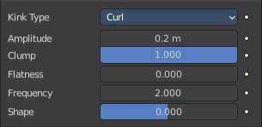
Curl, Radial, Wave, Braid
Curl - Children grow in a spiral around the parent hairs.
Radial - Children form around the parent a wave shape that passes through the parent hair.
Wave - Children form a wave, all in the same direction.
Braid - Children braid themselves around the parent hair.

Amplitude
The amplitude of the offset.

Clump
How much clump effects kink amplitude.

Flatness
How flat the hairs are.

Frequency
The frequency of the offset (1/total length). The higher the frequency the more rotations are done.

Shape
Where the rotation starts (offset of rotation).

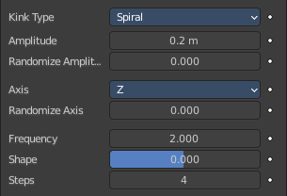
Spiral
Generates a spiral at the end of each hair.

Amplitude
The amplitude of the offset.

Randomize Amplitude
Give the amplitude a random variation.

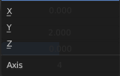
Axis
Which axis to use for offset.

Randomize Axis
Randomize the orientation.

Frequency
The frequency of the offset (1/total length). The higher the frequency the more rotations are done.

Shape
Where the rotation starts (offset of rotation).

Steps
Extra steps for resolution of special kink features.

Children panel - Type Interpolated
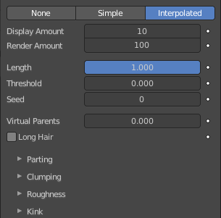
Children are emitted between the Parent particles on the faces of a mesh. They interpolate between adjacent parents. This is especially useful for fur, because you can achieve an even distribution. Some of the children can become virtual parents, which are influencing other particles nearby.

Display Amount
The number of children in the 3D Viewport.

Render Amount
The number of children to be rendered.

Length
Length of child paths.

Threshold
Amount of particles left untouched by child path length.

Seed
Offset in the random number table for child particles, to get a different randomized result.

Virtual Parents
Relative Amount of virtual parents.

Long Hair
Belongs to Hair particles. Calculate children that suit long hair well.

Children panel - Type Interpolated - Parting subpanel

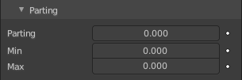
This panel belongs to Hair particles.

Parting
Creates parting in the children based on parent strands.

Min
Minimum root to tip angle. Tip distance / root distance for long hair.

Max
Maximum root to tip angle. Tip distance / root distance for long hair.

Children panel - Type Interpolated - Clumping subpanel
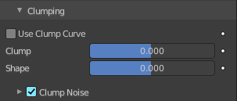
Clumping allows as the name says to break the even look, and clump particles together.

Use Clump Curve
Use a Curve instead of parameters to adjust the clumping.

Selecting Points
You can select curve points. This reveals two edit boxes for the x and y coordinate of this point.
Selected points can be moved around. Left click at them, hold the mouse button down and move them to a new location.

Adding Points
You can add new curve points by simply left clicking at the curve. Move the mouse to position them where you need it.

Navigation elements
The navigation elements at the top are described from left to right.

Zoom in and out
The two buttons with the magnifying glass at it zooms in and out in the curve window.

Tools
Tools is a menu where you can find some cuve related tools.

Reset View
Resets the curve windows zoom.

Vector Handle
Set handle type to Vector.

Auto Handle
Set handle type to Auto.

Extend horizontal
Extend the curve horizontally before the first and after the last curve point.

Extend vertical
Extend the curve vertically before the first and after the last curve point.

Auto Clamped Handle
Set handle type to Auto Clamped.

Reset Curve
Resets the curve to the initial shape.

Use Clipping
Clipping options. Set up clipping for the stroke.

Delete Points
Deletes selected curve points.

Clump
Clumping amount along child strands. The children may meet at their tip (1.0) or start together at their root (-1.0).

Shape
Form of Clump. Either inverse parabolic (0.99) or exponentially (-0.99).

Clump Noise
Creates random clumps around the parent hair.

Clump Noise Size
The size of clump noise.

